Downloading FileZilla to your computer
If you want to download FileZilla to your computer, then go to the following web address:
http://ninite.com/
[NiNite is a reliable site which does not download anything other than what you select]
Scroll to the bottom of the page & check FileZilla. Then click “Get Installer”. Refer to the image below for details.
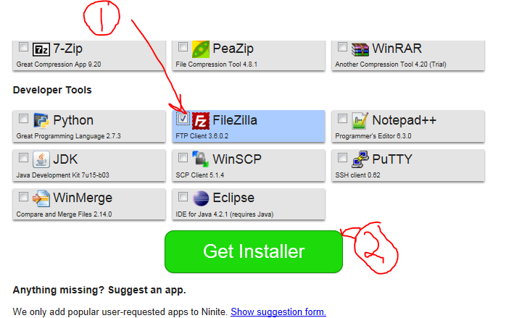

Click “Get Installer” to Install FileZilla → Then click Run
When finished, you will find a ShortCut link to FileZilla on your desktop. You can also click on Programs and find FileZilla there as well.

